[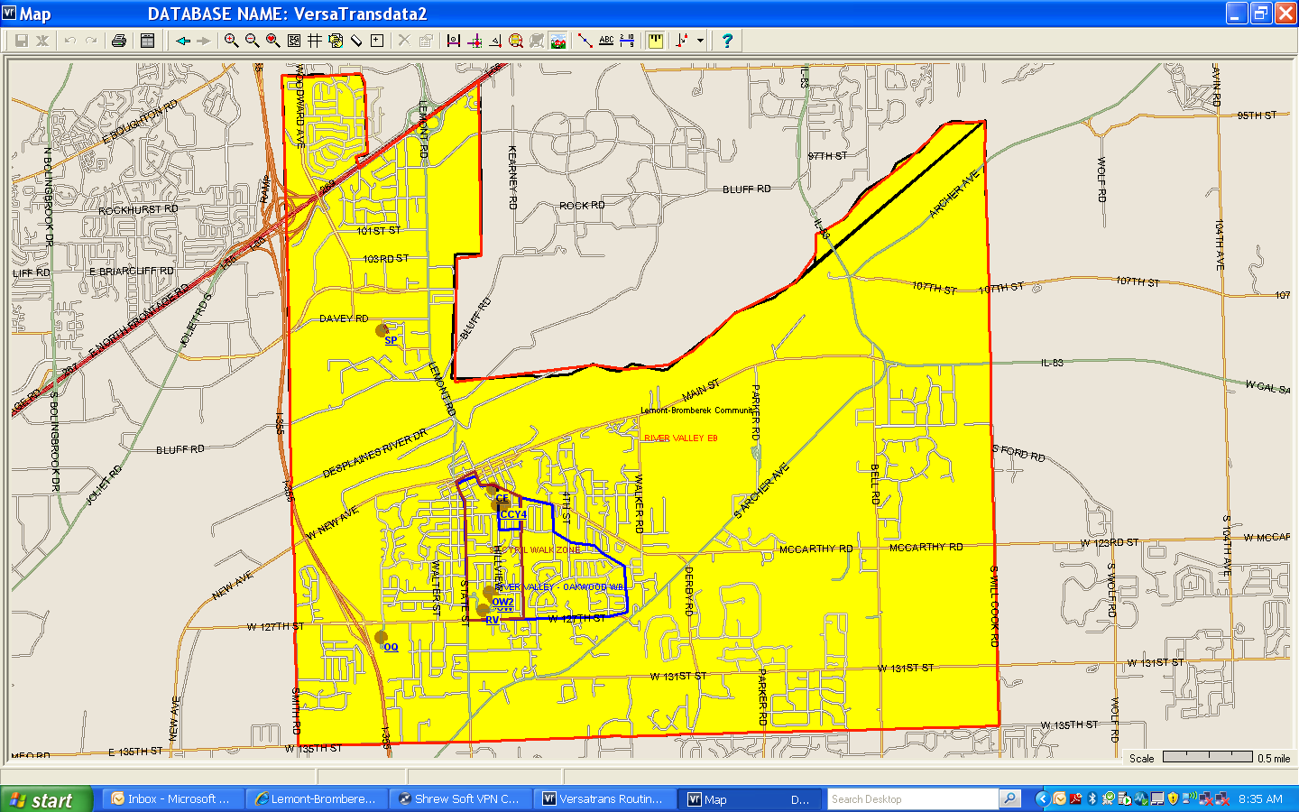](~$strict%20113A%20Borders.docx)